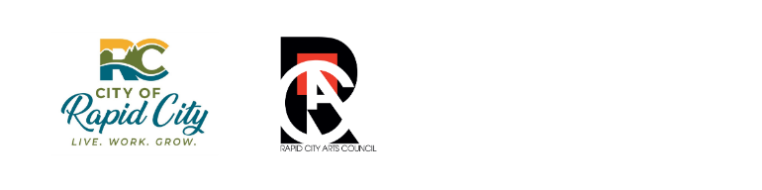

CITY ARTS INVESTMENT FUND
2024 GRANT APPLICATION FORM

Grant Program Contact  Rapid City Arts Council (RCAC)  Email: aif@thedahl.org  Phone: 605.394.1785  Important 2024 Dates  Friday, January 5, 5:00PM MT  Deadline for Questions: Please submit questions about the grant requirements in writing (emailed to aif@thedahl.org) before this deadline.  Monday, January 8  Responses to Questions Posted: All responses to questions received via email before the deadline on January 5th will be posted at rapidcityartscouncil.org/cityartsfund  Friday, January 26, 11:59PM MT  Submittal Deadline  (Late applications will not be considered)  Award Notification: February 29, 2024 (expected)  Grant Report Due: October 25, 2024 | Acceptable Application Submittal Methods  1. Email  Submit application materials to aif@thedahl.org, Subject: “2024 AIF Application - Organization Name”  2. Postal Service  Submit materials (postmarked by the submittal deadline) in a sealed envelope addressed to: Rapid City Arts Council, 713 7th St, Rapid City, SD 57701, ENC: AIF Application  3. In Person  Deliver materials in a sealed envelope labeled “RCAC/AIF Application” to RCAC staff at the main desk of the Dahl Arts Center, 713 7th St, Rapid City, SD  Late or incomplete applications will not be considered.  Meeting the application requirements does not ensure proposals will be funded.  Guidelines, application form and additional information available at: rapidcityartscouncil.org/cityartsfund

Application Instructions: Complete the application in the outline and format provided in this form. Only applications that conform to the outline and have required supporting documents attached will be considered.

Submittal Instructions: Submit completed application form and required supporting documents to RCAC by 11:59 PM MT, Friday, January 26, 2024, using one of the three “Acceptable Submittable Methods” listed on the first page of application form. Late or incomplete applications will not be considered. RCAC will email confirmation of successful submissions within two (2) business days.

Questions: Questions about the grant process or requirements may be submitted in writing to aif@thedahl.org. Inquiries must be delivered by 5:00PM, January 5, 2024. Only inquiries received in writing to aif@thedahl.org will receive a response. Do not contact any RCAC staff by telephone with any questions or comments pertaining to this grant. RCAC will reply directly to questions and post questions/answers at rapidcityartscouncil.org/cityartsfund on January 8, 2024.

2024 GRANT APPLICATION FORM
Please complete the following application form in the outline and format provided. There is no page limit.

Organization Information

Name of Organization:

Name of Program/Project (or season):

Legal Name, if applicable:

Federal Employer Identification Number:

Contact Name:
Phone:
Email:

Mailing Address (billing):

Where is your organization physically located?

What is your mission statement?

What is your annual operating budget?

List a specific dollar amount. Include any necessary explanations.

$

Requested Grant Amount
What amount of funding are you seeking? $
(Awards may not exceed $10,000, with exception for the municipal organizations under statute)

Proposed Project/Program
Please provide a succinct description of your program/project. Include key highlights of your project based on the grant guidelines and AIF Selection Criteria (item 8 of guidelines). Effective responses will align with the Selection Criteria, address feasibility and clearly explain how the proposed activities advance the goals of the Arts Investment Fund.

Program Dates

When will the program/project start?

When will the program/project end?

Describe the community your program serves:
Tell us about the community you propose to impact with your project/program.

Number of Participants Served:

Anticipated adults served:

Anticipated youths served:

Anticipated total participants:

Anticipated Rapid City residents:

How do you make your program accessible to people with disabilities?

What is your organization’s non-discrimination policy?
Award recipients must comply with applicable conscience protections and federal civil rights laws that prohibit discrimination based on race, color, national origin, disability, and age. Organizations whose policies do not comply with non-discrimination laws are not eligible to apply.

Required Supporting Documents

Please include the following attachments in your application submittal:

- Total budget for your program/project, including income and expense details
- List of current officers and board members
- Most recent financial statements prepared by certified public accountant or IRS 990
- IRS 501(c)(3) determination letter (new applicants only)

Certification
I certify that my organization has reviewed the 2024 Grant Guidelines in full as posted at: www.rapidcityartscouncil.org/uploads/2/9/0/8/2908437/2024_city_arts_investment_fund_grant_guidelines.pdf

I certify that the information contained in this application and all its supporting documents are true and correct to the best of my knowledge.

Signature _______________________________

Print Name:
Title:
Date of Signature:

